Project Profile

* **Project Profile**

|  |  |
| --- | --- |
| **Project Name:** | SERVERLESS DOCUMENT PUBLISHING APPLICATION |
| **Type of Application** | Single Page Application(SPA) |
| **Project Description:** | Feature-rich Resume Builder and News Letter is used for automating the process of Resume Writing. This would be facilitating the employees and Students to make and print their resumes in a proper format. In addition, it will be facilitating the higher management to search the employees and Students depending upon their skills sets and other attributes. Anotehr feature is News Letter is used for automating  newsletter to promote your business or product the content of a good marketing newsletter, apart from being attractive for the target audience, should always be factual and impartial, otherwise it would lose its credibility towards the customer. Feature that makes this application more efficient that Is ServerLess |
| **Team Size** | 01 |
| **Front End** | Angular CLI(1.7.1), Angualr Material(5.2.4) |
| **Database** | MongoDB(3.6) |
| **Tools used** | Node(9.5.0), express(4.16.3) ,RoboMongo 3T(1.1.1) |

Company Profile

**Company Profile**

|  |  |
| --- | --- |
| **Company Name** | Knowarth Technologies Pvt. Ltd. |
| **Company’s Description** | KNOWARTH Technologies is an IT services organization. KNOWARTH has been assisting companies with Technology Consulting, Software Prototyping, Development and with Support. Hence helping them reducing the worry about managing multiple vendor or partners. We have enabled them with a smarter solution, by being their One-stop Solution Partner. |
| **Working Address** | 11, Aryan Corporate Park, Near Shilaj Railway Crossing, Thaltej, Ahmadabad, Gujarat 380059 |
| **E-Mail Address** | [contact@knowarth.com](mailto:contact@knowarth.com" \t "https://www.knowarth.com/_Blank) |
| **External Guide** | Mitesh Gajjar |
| **Contact No.** | 9974591748 |
| **E-Mail Address** | [mitesh.gajjar@knowarth.com](mitesh.gajjar@knowarth.com ) |

I

Introduction to tools

* **Introduction to Tools**
* **Front End Tool:**

**Angular(5.2.6):**

* The [Angular CLI](https://cli.angular.io/) is a command line interface tool that can create a project, add files, and perform a variety of ongoing development tasks such as testing, bundling, and deployment.
* The Angular CLI is a tool to initialize, develop, scaffold and maintain [Angular](https://angular.io/) applications.
* Angular cli is a command line interface to scaffold and build angular apps using nodejs style (commonJs) modules. Not only it provides you scalable project structure, instead it handles all common tedious tasks for you out of the box.

**Angualr Material(5.2.4):**

* AngularJS Material is both a UI Component framework and a reference implementation of Google's [Material Design Specification](https://material.io/guidelines/material-design/" \t "https://material.angularjs.org/HEAD/_blank).
* Angular Material is a UI component library for Angular JS developers. Angular Material components help in constructing attractive, consistent, and functional web pages and web applications while adhering to modern web design principles like browser portability, device independence, and graceful degradation. It helps in creating faster, beautiful, and responsive websites. It is inspired by the Google Material Design
* **Back End Tool:**

**MongoDB(3.6):**

* MongoDB is an open-source document database that provides high performance, high availability, and automatic scaling. MongoDB obviates the need for an Object Relational Mapping (ORM) to facilitate development.
* A record in MongoDB is a document, which is a data structure composed of field and value pairs. MongoDB documents are similar to JSON objects. The values of fields may include other documents, arrays, and arrays of documents.

* **Tools Used:**

**Node(9.5.0):**

* Node.js is an open source server framework.
* Node.js is free.
* Node.js runs on various platforms (Windows, Linux, Unix, Mac OS X, etc.)
* Node.js uses JavaScript on the server.
* Node.js runs single-threaded, non-blocking, asynchronously programming, which is very memory efficien.

**express(4.16.3):**

* [Express](https://expressjs.com/) is the most popular Node web framework, and is the underlying library for a number of other popular [Node web frameworks](https://expressjs.com/en/resources/frameworks.html). It provides mechanisms to:
  + - Write handlers for requests with different HTTP verbs at different URL paths (routes).
    - Integrate with "view" rendering engines in order to generate responses by inserting data into templates.
    - Set common web application settings like the port to use for connecting, and the location of templates that are used for rendering the response.
    - Add additional request processing "middleware" at any point within the request handling pipeline.

**RoboMongo 3T(1.1.1):**

* Robo 3T (formerly Robomongo) is the free lightweight GUI for MongoDB enthusiasts. MongoDB GUI with embedded shell.

System Study

* **System Study:**
* **Existing System**
* Document publishing is the creation of documents using [different layout](https://en.wikipedia.org/wiki/Page_layout" \o "Page layout) skills on Web Application primarily for print.
* Document publishing Application can generate layouts and publishing Documents like NewsLetter, Resume.
* **Proposed System**
* Admin can Create form structure for getting the Details.
* User can fill up the forms for Resume and NewsLetter.
* Admin or higher management to search the employees and Students depending upon their skills sets and other attributes.
* Anotehr feature is News Letter is used for automating  newsletter to promote your business or product.
* User can select Template of Resume and Publish the Resume in different format.
* User can select Template of News Letter and Publish the News Letter in different format.
* **Scope of the Proposed System**
* we describe what features are in the scope of the software and what are not in the scope of the software to be developed.
* User should be able to Login and Log out.
* User should be able to select Resume.
* User should be able to select News Letter.
* User should be able to Add\Update\Delete\view details for Resume.
* User should be able to Add\Update\Delete\view for News Letter.
* User Should be able to Publish or Download Document.
* Admin Should be able to Login and Log out..
* Admin should be able to Add\Update\Delete\Display form structure for Resume.
* Admin should be able to Add\Update\Delete\Display form structure for News Letter.
* Admin should be able to Add\Update\Delete\Display Template for News Letter.
* Admin should be able to Add\Update\Delete\Display Template for Resume.
* Admin should be able to Download Document or Publish Document

* **Aim and Objective of the Proposed System**

A website is developed to facilitate the administration to manage the various users Resumes information and update the information about diferent departments using NewsLetter . Structure of form is Decided by administration so that user can fill up the forms details and Publish the Documet.

Objective of doing this project is to manage users or Employees or Students Information by their professional Resumes . another objective is that the frequently update the different news regarding any product or department using NewsLetter. Some of the user requirement and objective of this website is as under

* The users can only use the application to fill necessary details for Resume . This means that the user have to be able to fill details for resume, choose a Templates from Templates and then export to html,pdf.
* The administrators also interact with the web portal. They are managing the overall system so there is no incorrect information within it. The administrator can manage the information for each users like exports multiple resume at time.

Feature that makes this application more efficient that Is ServerLess. ServerLess is a cloud computing code execution model in which the cloud provider fully manages starting and stopping of a function's container platform as a service (PaaS) as necessary to serve requests, and requests are billed by an abstract measure of the resources required to satisfy the request

Microservices - also known as the microservice architecture - is an architectural style that structures an application as a collection of loosely coupled services, which implement business capabilities. The microservice architecture enables the continuous delivery/deployment of large, complex applications. It also enables an organization to evolve its technology stack

* **Feasibility Study:**
* **Operational Feasibility:**

Proposed system is advantageous only if it meets the organizations operating requirements. In simple words this test of feasibility decides if the system will work or not when it is developed and implemented. Are there any Hindrances for system implementation?Here are questions that help to test the operational feasibility and answers to justify the operational feasibility of the project.

* **Is the user happy with existing system?**

In current system user have facility and environment it contains information about question and answer.

* **Is there sufficient support for project from management?**

Yes, the management people are quite keen to see the new system developed.the management is also eager to implement the system and gain more business with more else.

* **Have users been involved in the planning and development of the project?**

Yes,the user and agent have actively contribute in the development and analysis of the system.

Hence,operational feasibility covers two aspects.one is technical performance and other is acceptance by user the system Is operationally feasible as it is very interactive and user friendly.it fulfills all the clients requirements.

* **Technical Feasibility:**
* Technical Feasibility of a project determines whether a project can be developed using the technology on hand.
* The System is technically feasible as the front-end required for it is available and already installed.
* System is developed by using code as a front end. For displaying and modification of data web service is called. In this way system will allow website to communicate with server.

**Minimum requirement to establish connection with website properly**.

* 512 MB of RAM
* 80 GB Hard drive
* Processor Higher than 1.2 GHz.
* Good internet connection
* **Economical Feasibility:**
* A system that can be developed technically and that will be used if installed must still be good investment for the organization.Financial benifts must equal or exceed the investment following are the major points considered while testing for the economic feasibility of the system.
* **The cost of the hardware and software**

The cost or hardware and software will not be too high.It’s one time investment in the system.

* **The benefits in the form of more business and citizen satisfaction.**

The system will be very useful to the user.Users just have to download the application on Mobile which is light weight in size.

System Analysis

Requirements Specification

**System Modules:**

|  |  |
| --- | --- |
| User Login Page | This Page is for User to Login\Logout into the system. |
| User Dashboard | The User dashboard provide the options for User to select Resume,News Letter. |
| Resume Page | Afer Selecting the Resume User should be able to Add\Update\Delete\View details for Resume. |
| News Letter Page | Afer Selecting the News Letter User should be able to Add\Update\Delete\View details for News Letter. |
| Publish Page | Thirough this page user Should be able to Publish or Download Document in PDF,WORD format |
| Admin Login Page | This Page is for Admin to Login\Logout into the system |
| Admin Dashboard | The Admin dashboard provide the options for Admin to select Resume,News Letter. |
| Modify Resume Form Structure Page | Through this page the Admin can Add\Update\Delete\Display form structure for Resume. |
| Modify NewsLetter Form Structure Page | Through this page the Admin can Add\Update\Delete\Display form structure for News Letterr. |
| Modify Resume Template Structure Page | Admin should be able to Add\Update\Delete\Display Template for News Letter. |
| Modify NewsLetter Template Structure Page | Admin should be able to Add\Update\Delete\Display Template for Resume. |
| Publish Page | Admin should be able to Download Document or Publish Document PDF,WORD format. |

* **User should be able to Login and Logout**

**Input:**  Username and password

**Process:**

* + The User shall be able to Login by providing the username and password .

**Output:** valid user redirected to Dashboard.invalid user get proper message.

* **User Dashboard**

**Process:**

* + The User Dashboard Provide two options Resume and NewsLetter.
  + The resume option shall be able to get the user information for the build resume.
  + The NewsLetter option shall be able to get the information for the build NewsLetter.
* **Resume Page**

**Input:**

* + - **Basic Details:**
      * First_Name
      * Last_Name
      * DOB
      * Email
      * Gender
      * Country
      * City
      * Address
      * Contact
      * Social Media
        + Website
        + twitter
        + Skype
        + Linked In
        + Facebook
        + Quora
    - **Qualification Details**
      * Degree Name
      * Institute Name
      * University
      * Statuse
      * Year of passing
      * Address
      * CGPA
    - **Work Experience**
      * Designation
      * Company Name
      * Starting date
      * ending date
      * Status
      * Country
      * city
      * Responsibility
      * Reference Contact
      * Reference Contact Designation
    - **Project Details**
      * Project Title
      * Technologies
      * Duration
      * Description
    - **Achievements Details**
      * Certificate name
      * Description
    - **Skills Details**
      * Categories
      * Technical Skills
        + Web Server
        + Languages/Technologies
        + Mobile Technology
        + Development Tools
        + Libraries & Framework
        + Repositories
        + Database
        + Operating Systems
        + Others
    - **Honor Award**
      * Award Name
      * Month
      * Year
      * Company/institute
      * Description
    - **Languages**
      * Language Name
      * Read
      * Write
      * Speak
    - **Hobbies**
      * Hobby Name
    - **Profile Photo**
      * Profile Pic-image

**Process:**

* + - * Allow user to fill up Basic Details
      * Allow user to fill up Qualification Details
      * Alllow user to fill up Work Experience Details.
      * Allow user to fill up Project Details.
      * Allow usre to fill up Achievements Details.
      * Allow user to fill up Skills Details.
      * Allow user to fill up Honor Award.
      * Allow user to fill Languages Details.
      * Allow user to fill Hobbies Details.
      * Allow user to upload Profile Photo.

**Output:**

* + - * User get proper message after submitting Details
* **NewsLetter Page**

**Input:**

* News Letter Details
* Select Department Name
* Name/title
* Picture
* Description
* Contact
* Social Media link

**Process:**

* + - * Allow user to fill up NewsLetter Details

**Output:**

* + - * User get proper message after submitting Details
* **Publish Page:**

**Input:**

* Template Name
* Export Date & Time

**Process:**

* User should be able to view template.
* User Should be able to download Document.
* User Should be able to Publish Document

**Output:** User get published or downloaded file.

* **Admin should be able to Login and Logout**

**Input:**  Username and password

**Process:**

* + The Admin shall be able to Login by providing the username and password .

**Output:** valid Admin redirected to Dashboard.invalid user get proper message.

* **AdminDashboard**

**Process:**

* + The Admin Dashboard Provide Lisrting of Users Resumes .
  + The Admin Dashboard Provide Lisrting of Resumes Structure.
  + The Admin Dashboard provide Listing of Users NewsLetter.
  + The Admin Dashboard provide Listing of NewsLetter Template.
  + The Admin Dashboard Provide Lisrting of Resumes Template.
  + The Admin Dashboard provide facilty of Publish and Dowaload Resume and NewsLetter.
* **Modify Resume Form Structure Page**

**Input:**

Structure Name

Details

**Process:**

* + Admin should be able to Add Structure for Resume.
  + Admin should be able to Update Structure for Resume.
  + Admin should be able to Delete Structure of Resume.
  + Admin should be able to View Structure of Resum.

**Output:** Admin get proper messaeg after modify Structure.

* **Modify News Letter Structure Page**

**Input:**

Structure Name

Details

**Process:**

* + Admin should be able to Add Structure for News Letter.
  + Admin should be able to Update Structure for News Letter.
  + Admin should be able to Delete Structure of News Letter.
  + Admin should be able to View Structure of News Letter.

**Output:** Admin get proper messaeg after modify Structure.

* **Modify Resume Template Page**

**Input:**

* Template Name
* Header
* Footer
* Background image
* Thumbnail
* Uploaded date
* Designed By

**Process:**

* + Admin should be able to Add Template for Resume.
  + Admin should be able to Update Template of Resume.
  + Admin should be able to Delete Template of Resume.
  + Admin should be able to view Template of Resume.

**Output:** Admin get proper messaeg after modify Structure.

* **Modify News Letter Template Page**

**Input:**

* Template Name
* Header
* Footer
* Background image
* Thumbnail
* Uploaded date
* Designed By

**Process:**

* + Admin should be able to Add Template News Letter .
  + Admin should be able to Update Template of News Letter .
  + Admin should be able to Delete Template for of News Letter.
  + Admin should be able to view Template for of News Letter.

**Output:** Admin get proper messaeg after modify Structure

* **Publish Page**

**Input:**

* Template Name -char-Require
* User Name-char-Require
* Export Date-date-Require
* Export by-char-Require

**Process:**

* + Admin should be able toPublish or Download multiple News Letter and Resumes .

USECASE DIAGRAM

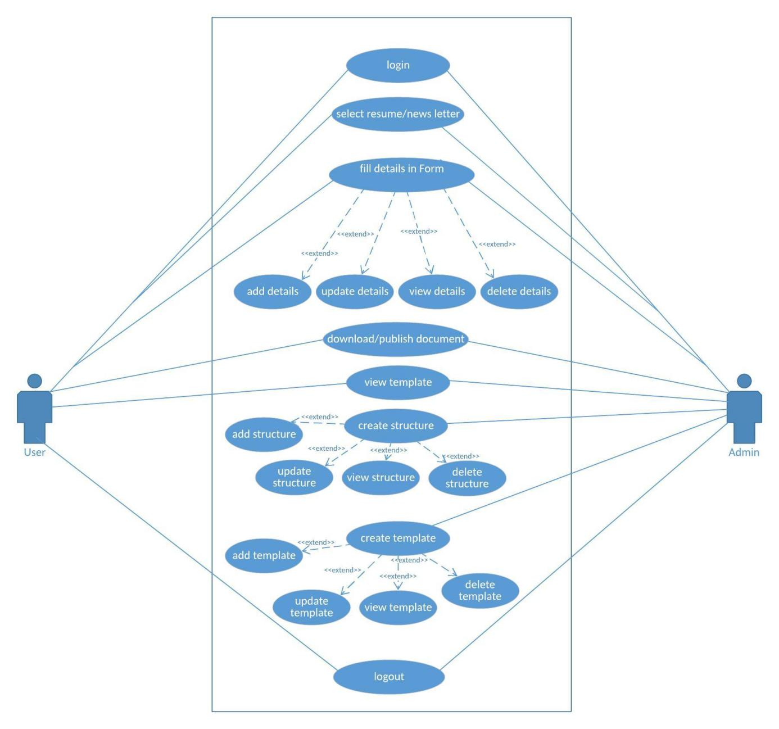

Activity Diagram

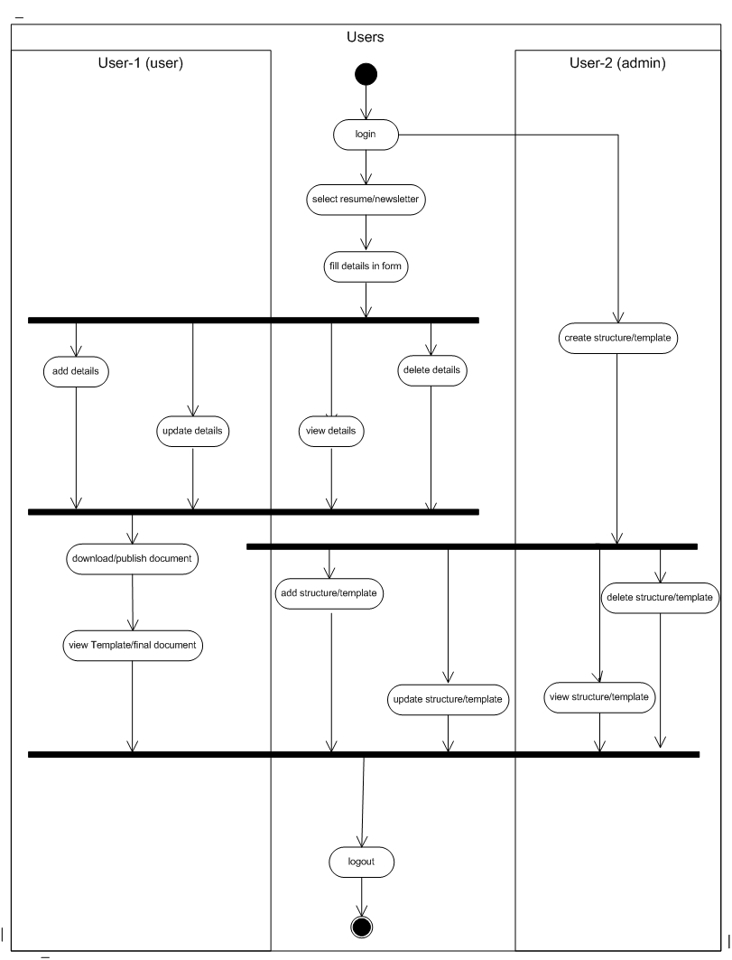

SEQUENCE DIAGRAM

**USER:**

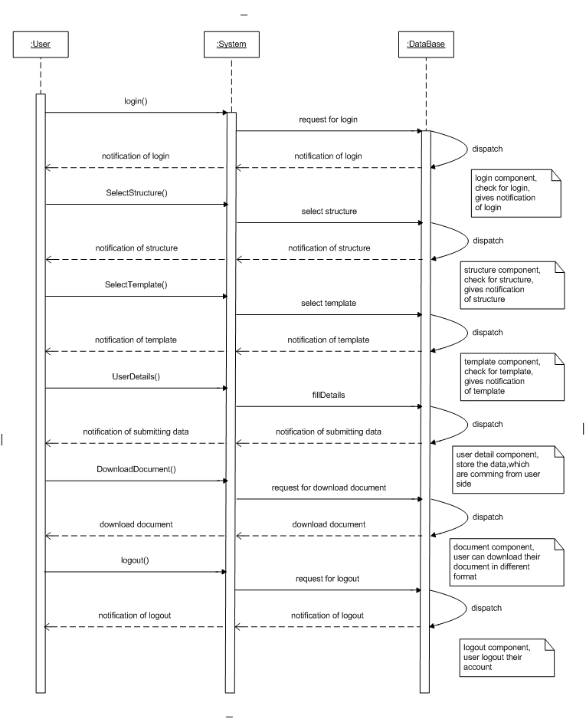

**ADMIN:**

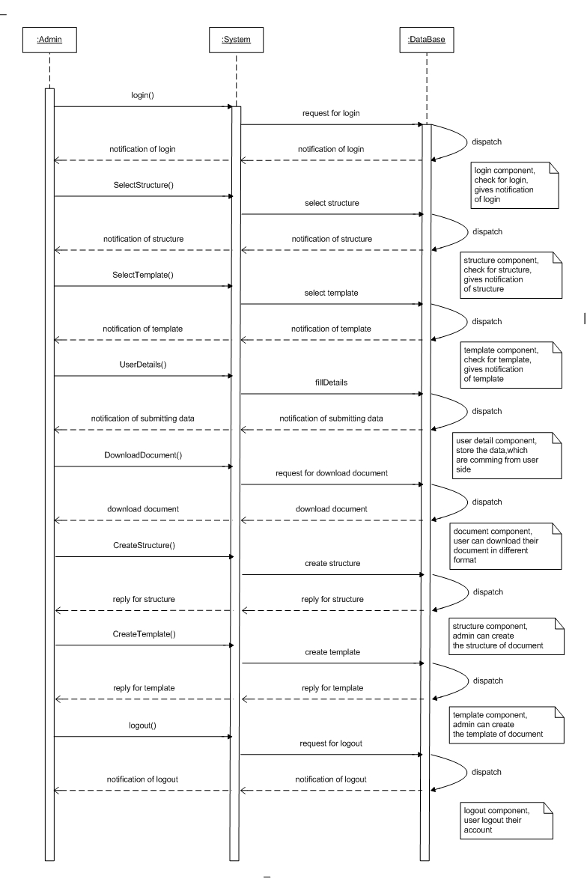

System Design

Data dictionary

1. User Collection

|  |  |  |
| --- | --- | --- |
| **Field Name** | **Data Type / Default Size** | **Description** |
| _id | ObjectID()**-** | It is by Default Created by the Mongo db, and unique every time |
| name | string | Simply name of the User |
| email | string | Unique Email ID of the User |
| username | string | Name with uniquely identify |
| password | string | User password which is encrypt. |

1. Admin Collection

|  |  |  |
| --- | --- | --- |
| **Field Name** | **Data Type / Default Size** | **Description** |
| _id | ObjectID() | It is by Default Created by the Mongo db, and unique every time |
| username | string | Name with uniquely identify |
| password | string | User password which is encrypt. |

1. ResumeStructutre Collection

|  |  |  |
| --- | --- | --- |
| **Field Name** | **Data Type / Default Size** | **Description** |
| _id | ObjectID() | It is by Default Created by the Mongo db, and unique every time |
| BasicDetailschema | Object | Basic Details About user |
| qualificationDetailSchema | Object | Qualification Details About user |
| WorkExpSchema | Object | WorkExperience of user |
| ProjectDetailSchema | Object | Project details of user |
| AchievementDetailSchema | Object | Achivement details of user |
| SkillDetailSchema | Object | Skills details of user |
| HonorAwardSchema | Object | HonorAward deials of user |
| HobbySchema | Object | Hobbies of user |
| languageSchema | Object | Language Details of user |
| ProfilePicSchema | Object | Profile Pic Of user |

1. NewsLetter Structure Collection

|  |  |  |
| --- | --- | --- |
| **Field Name** | **Data Type / Default Size** | **Description** |
| _id | ObjectID() | It is by Default Created by the Mongo db, and unique every time |
| StructureschemaNewsLetter | Object | Details about New Letter |

1. UserDocument Collection

|  |  |  |
| --- | --- | --- |
| **Field Name** | **Data Type / Default Size** | **Description** |
| _id | ObjectID() | It is by Default Created by the Mongo db, and unique every time |
| Template Name | String | Temolate Name |
| Export Date & Time-date | Date&Time | Date and Time of Exported Document |

1. ResumeTemplate Collection

|  |  |  |
| --- | --- | --- |
| **Field Name** | **Data Type / Default Size** | **Description** |
| _id | ObjectID() | It is by Default Created by the Mongo db, and unique every time |
| Template Name | String | Temolate Name |
| Header | Image | Tmeplate Header image |
| Footer | Image | Template Footer image |
| Background image | Image | Template Background image |
| Thumbnail | Image | Template Thumbnail image |
| Uploaded date | Date | Template Creation Date |
| Designed By | String | Template Creater Name |

1. NewsLetterTemplate Collection

|  |  |  |
| --- | --- | --- |
| **Field Name** | **Data Type / Default Size** | **Description** |
| _id | ObjectID() | It is by Default Created by the Mongo db, and unique every time |
| Template Name | String | Temolate Name |
| Header | Image | Tmeplate Header image |
| Footer | Image | Template Footer image |
| Background image | Image | Template Background image |
| Thumbnail | Image | Template Thumbnail image |
| Uploaded date | Date | Template Creation Date |
| Designed By | String | Template Creater Name |

1. AdminDocuments Collection

|  |  |  |
| --- | --- | --- |
| **Field Name** | **Data Type / Default Size** | **Description** |
| _id | ObjectID() | It is by Default Created by the Mongo db, and unique every time |
| Template Name | String | Selected Temolate Name |
| Export Date | Date | Template Exported Date |
| Export by | String | Template Exported By |

Screen Layouts

1) LOGIN

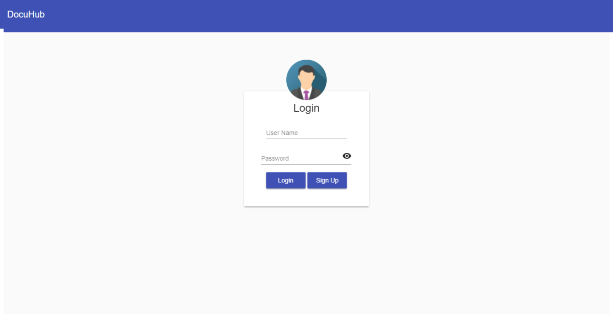

2) Dashboard

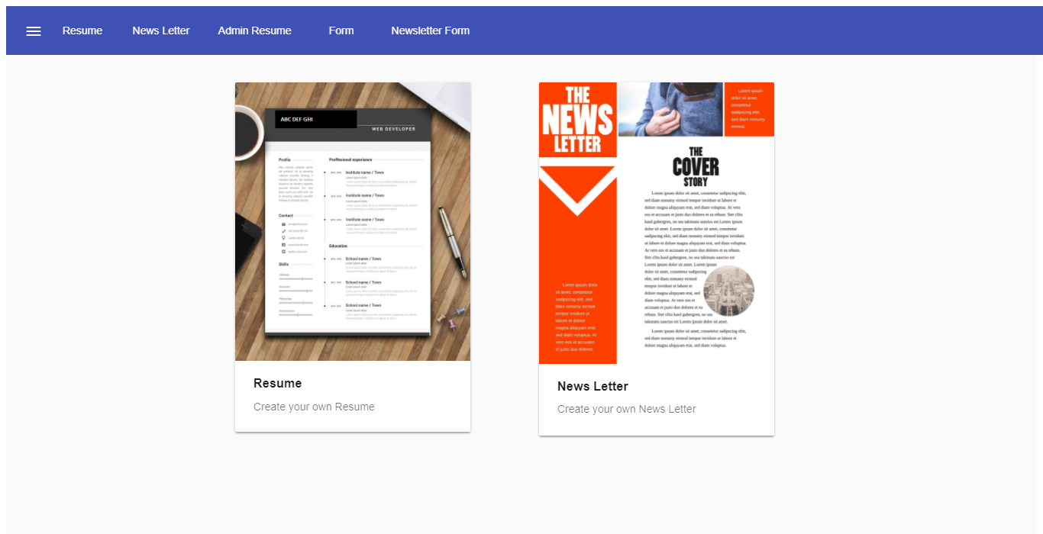

1. Resume Structure

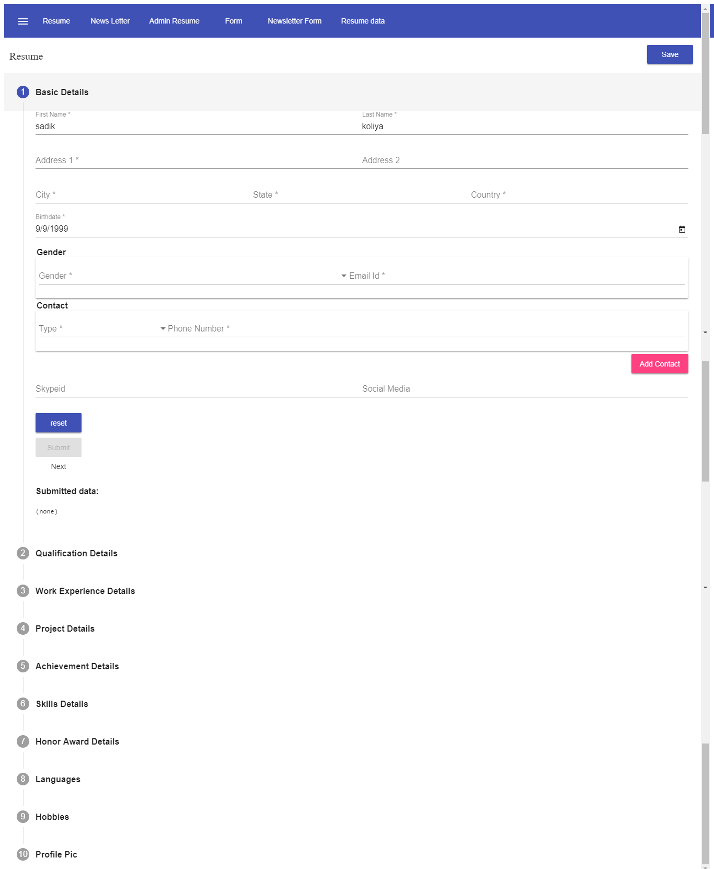

System Testing

Future enhancement

bibliography/references

**Web**

Mongo DB : <https://docs.mongodb.com/>

Express : <http://expressjs.com/en/api.html>

Angular JS : <https://angular.io/>

<https://material.angular.io/>

Node JS : <https://nodejs.org/api/>

NPM : <https://www.npmjs.com/>

**Book**

* Building Serverless web Applications
  + - Author: Diego Zanon
    - Reviewer: Chintan Mehta